|  |
| --- |
| UAHealth Bit Vault Software Design Specification |
| CPE 656/658 Software Studio |
| Timothy R. Wilkins  Whit J. Sisulak  Glen L. Riden  James J. Duggan IV |

10/11/2015

# Revision History

|  |  |  |  |
| --- | --- | --- | --- |
| Revision # | Revision Date | Description of Change | Author |
| 0.1 | 10/12/15 | Initial Draft | J. Duggan  W. Sisulak |
|  |  |  |  |
|  |  |  |  |
|  |  |  |  |

# Table of Contents

Revision History i

Table of Contents ii

1 Introduction 1

1.1 Purpose 1

1.2 Scope 1

1.3 Definitions, Acronyms, and Abbreviations 2

1.4 References 2

1.5 Overview 2

2 System Architecture Description 2

3 Detailed Description of Components 2

Software Configuration Plan

# Introduction

## Purpose

The purpose of this document is to provide a detailed design of the UAHealth Bit Vault software projects. This document should be used as a reference for the software system architecture and detailed design descriptions of the system components. The intended audience for this document includes system developers, testers, customers, and any other stakeholders.

## Scope

In the sections below an overview will be given for the two pieces of software that will be required to fulfill the requirements proposed by our customer. Next there will be a brief overview of what will be required in the software configuration plan.

### Data Collection

The data collection portion of this project will consist of the following. There are two different medical devices to be used for this project that record various types of data. The data provided by these devices consists of different file formats, and the data is different from device to device. The software will have to determine the contents of each file and how to process them. Due to how long data transfers take to download the data from a device, there may be a need to convert the data from a binary format to another format in order to speed up the process of getting data off the device. The software needs to able to take in files provided by the medical devices and be able to translate them in a way where they can be stored in a database. The software needs to run in the background of a PC and wait for files that need to be processed. The software will have to interact with a database to insert the data that has been processed in order for the data to be stored for later analysis. The software should allow for some basic configuration such as designating a folder on the PC to be a listener. Files moved or copied into this folder will be processed by the software when they are added. The software should have the ability to process multiple files if more than one is placed into the processing folder at a time.

### Data Analysis

Data analysis software needs to be created to analyze the data that is captured from the data collection tool mentioned above. This piece of software will be a separate stand-alone web application. The software needs to perform data analysis over different intervals of time such as one week, one month, etc. There will need to be some way to manage user access to the various medical data that has been inserted into the database that this software will access. Below are some proposed data analysis ideas that can be incorporated into the project.

* Simple Moving Average
* Data correlation discovery between the multiple devices.
* Possibly determine when an individual moves from walking to running or simply being able to identify the activities that were being performed while the data was being captured.

The data analysis possibilities will likely not fully be realized until the project team understands the different types of data that are available. Also, there will need to be collaboration with the customer for additions or changes to the data measurements provided by this software. The web application will have to have different levels of user access which will be defined later in this document.

## Definitions, Acronyms, and Abbreviations

|  |  |
| --- | --- |
| SDD | Software Design Document / Software Design Specification |
|  |  |
|  |  |
|  |  |

## References

IEEE Std 1016-1998, IEEE Standard for Software Design Specification

## Overview

The remainder of this design specification document addresses the software system architecture, detailed design information for the various system components, and the database schema design. Each major section will be broken into two pieces each detailing the design criteria for the two pieces of software the make the UAHealth Bit Vault.

# System Architecture Description

## Overview of Components

### Data Collection

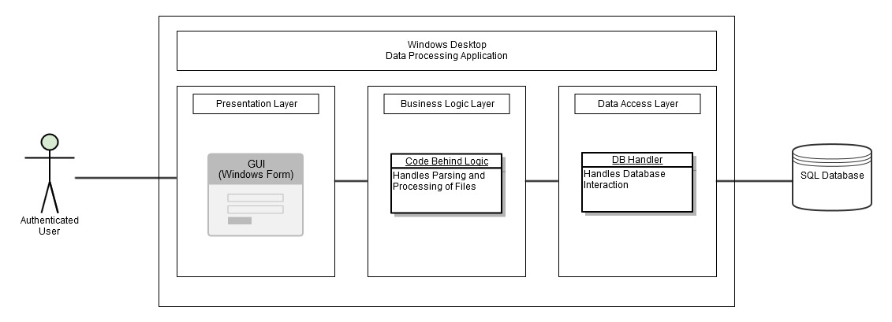

**Figure 2.1**: Data Collection Architectural Overview

The data processing application is a Windows desktop application that will be installed on the client machine and ran from there. The application is comprised of and encompasses the presentation, business logic, and data access layers. The system interacts with the end user via a windows form GUI and with an external SQL database hosted on a remote server. It is assumed that the user is authenticated to use the application.

* The presentation layer consists of a windows form GUI. It will have a section to browse to a directory for file processing and also will have an area to drag and drop files for processing. It will have a button to initiate the processing of files once they have been identified and will return to the user a display of the results once completed.
* The business logic layer will consist of all the back end code comprised of classes to handle the parsing and processing of files. It will use the DB handler in the data access layer to interact with the database and the front end GUI to receive data from and display results back to the user.
* The data access layer will consist of all the back end code needed to interact with an external SQL database utilizing the data access library of choice. Examples include ADO.NET (OleDb, ODBC), Entity Framework, or any other chosen data interaction libraries. A precondition that the host computer is connected to the internet exists.

### Data Analysis

# Detailed Description of Components